

**Project Status Report**



**Project Name: SUSAN ICE STORE ORDERING AND INVENTORY SYSTEM**

**Department:**

**Focus Area:**

**Product/Process:**



**Prepared By:**

|  |  |
| --- | --- |
| **Document Owner(s)** | **Project/Organization Role** |
| Leonard Potian | Project Manager/Programmer |
| Nelaine Valdez | Document Manager/Programmer |
|  |  |

**Project Status Report Version Control**

|  |  |  |  |
| --- | --- | --- | --- |
| **Version** | **Date** | **Author** | **Change Description** |
| 1.0 | 06/30/17 | Leonard Potian | Start of improving our system and adding the features that client needs. |
|  |  |  |  |
|  |  |  |  |
|  |  |  |  |

**TABLE OF CONTENTS**

1 PROJECT STATUS REPORT PURPOSE 3

2 PROJECT STATUS REPORT TEMPLATE 3

2.1 Project Status Report Details 3

2.2 Project Status Report Template 3

3 PROJECT STATUS REPORT APPROVALS 3

4 APPENDICES 3

4.1 Document Guidelines 3

4.2 Project Status Report Sections Omitted 3

# PROJECT STATUS REPORT PURPOSE

The purpose of this report is the progress of our system and the improvements that implement.

.



# PROJECT STATUS REPORT TEMPLATE

## Project Status Report Details

This is the third progress report requires the

[Status of the Project]

* + Our system is all about ordering and inventory system.
  + The team still improving the system
  + Improving the graphic user interface(GUI)
  + Adding some features that the users need.

## Project Status Report Template

|  |  |  |
| --- | --- | --- |
| Project Name | | |
| Prepared By:  Leonard Potian | Date:  06/29/2017 | Reporting Period:  06/28/17 to 07/4/17 |
| Project Overall Status:  The overall progress of the system is 40% based on what the team know. | | |
| Project Summary:  All documents in CSPOJ last term are in the git-hub and the source codes of the system. | | |

# 

3 PROJECT STATUS REPORT APPROVALS

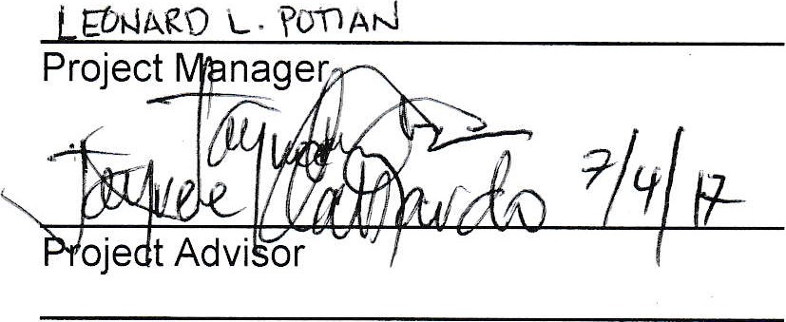

Client

Sponsor

Prepared

by

Approved

by

# APPENDICES

## Document Guidelines

## Project Status Report Sections Omitted

